НАЦІОНАЛЬНИЙ ТЕХНІЧНИЙ УНІВЕРСИТЕТ УКРАЇНИ
«КИЇВСЬКИЙ ПОЛІТЕХНІЧНИЙ ІНСТИТУТ»
ФАКУЛЬТЕТ ІНФОРМАТИКИ І ОБЧИСЛЮВАЛЬНОЇ ТЕХНІКИ
КАФЕДРА ОБЧИСЛЮВАЛЬНОЇ ТЕХНІКИ

Лабораторна робота №5
з дисципліни «Архітектура комп’ютерів 2»

Виконав:
студент ІІІ курсу
групи ІО-83
Крамар В.П.

Перевірив:
Нікольський С.

Київ 2020 р.

Посилання на репозиторій: https://github.com/viktorkramar/AK2_Lab5

Виконання завдання Basic:

Код програми:
/*
* Copyright (c) 2017, GlobalLogic Ukraine LLC
* All rights reserved.
*
* Redistribution and use in source and binary forms, with or without
* modification, are permitted provided that the following conditions are met:
* 1. Redistributions of source code must retain the above copyright
* notice, this list of conditions and the following disclaimer.
* 2. Redistributions in binary form must reproduce the above copyright
* notice, this list of conditions and the following disclaimer in the
* documentation and/or other materials provided with the distribution.
* 3. All advertising materials mentioning features or use of this software
* must display the following acknowledgement:
* This product includes software developed by the GlobalLogic.
* 4. Neither the name of the GlobalLogic nor the
* names of its contributors may be used to endorse or promote products
* derived from this software without specific prior written permission.
*
* THIS SOFTWARE IS PROVIDED BY GLOBALLOGIC UKRAINE LLC ``AS IS`` AND ANY
* EXPRESS OR IMPLIED WARRANTIES, INCLUDING, BUT NOT LIMITED TO, THE IMPLIED
* WARRANTIES OF MERCHANTABILITY AND FITNESS FOR A PARTICULAR PURPOSE ARE
* DISCLAIMED. IN NO EVENT SHALL GLOBALLOGIC UKRAINE LLC BE LIABLE FOR ANY
* DIRECT, INDIRECT, INCIDENTAL, SPECIAL, EXEMPLARY, OR CONSEQUENTIAL DAMAGES
* (INCLUDING, BUT NOT LIMITED TO, PROCUREMENT OF SUBSTITUTE GOODS OR SERVICES;
* LOSS OF USE, DATA, OR PROFITS; OR BUSINESS INTERRUPTION) HOWEVER CAUSED AND
* ON ANY THEORY OF LIABILITY, WHETHER IN CONTRACT, STRICT LIABILITY, OR TORT
* (INCLUDING NEGLIGENCE OR OTHERWISE) ARISING IN ANY WAY OUT OF THE USE OF THIS
* SOFTWARE, EVEN IF ADVISED OF THE POSSIBILITY OF SUCH DAMAGE.
*/

#include <linux/init.h>
#include <linux/module.h>
#include <linux/moduleparam.h>
#include <linux/printk.h>
#include <linux/types.h>

MODULE_AUTHOR("Kramar Viktor IO-83");
MODULE_DESCRIPTION("Hello, world in Linux Kernel Training");
MODULE_LICENSE("Dual BSD/GPL");

static uint repeat = 1;
module_param(repeat,uint,0);
MODULE_PARM_DESC(repeat, "Output Repeat");

static int __init hello_init(void)
{
uint i = 0;

printk(KERN_INFO "Repeat number: %d\n", repeat);

if(repeat == 0) {
printk(KERN_WARNING "Parameter value = 0");
}else if(repeat >=5 && repeat <= 10) {
printk(KERN_WARNING "Parameter value between 5 and 10");
} else if(repeat > 10) {
printk(KERN_ERR "Parameter value > 10");
return -EINVAL;
}

for(i = 0; i < repeat; i++){
printk(KERN_INFO "Hello, world!\n");
}
return 0;
}

static void __exit hello_exit(void)
{
/* Do nothing here right now */
}

module_init(hello_init);
module_exit(hello_exit);

insmod без параметра:
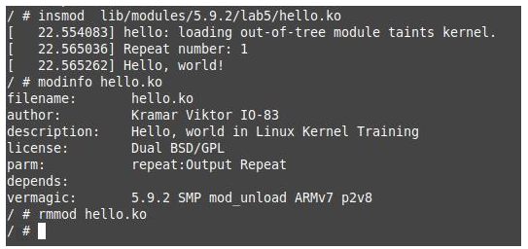

insmod з нулевим параметром:
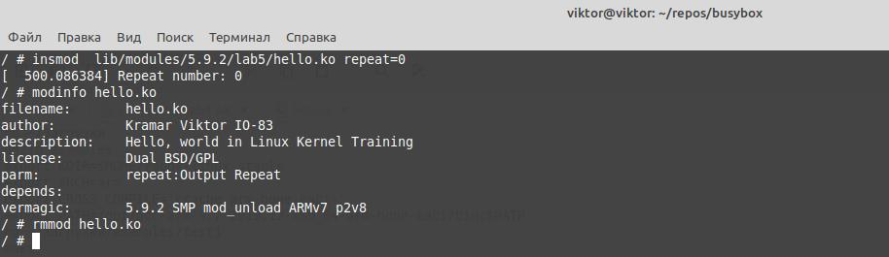

insmod з параметром 6:
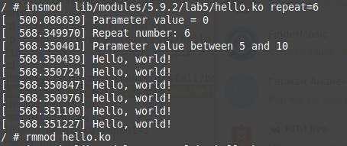

insmod з параметром 12:
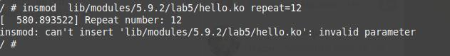
modinfo:
